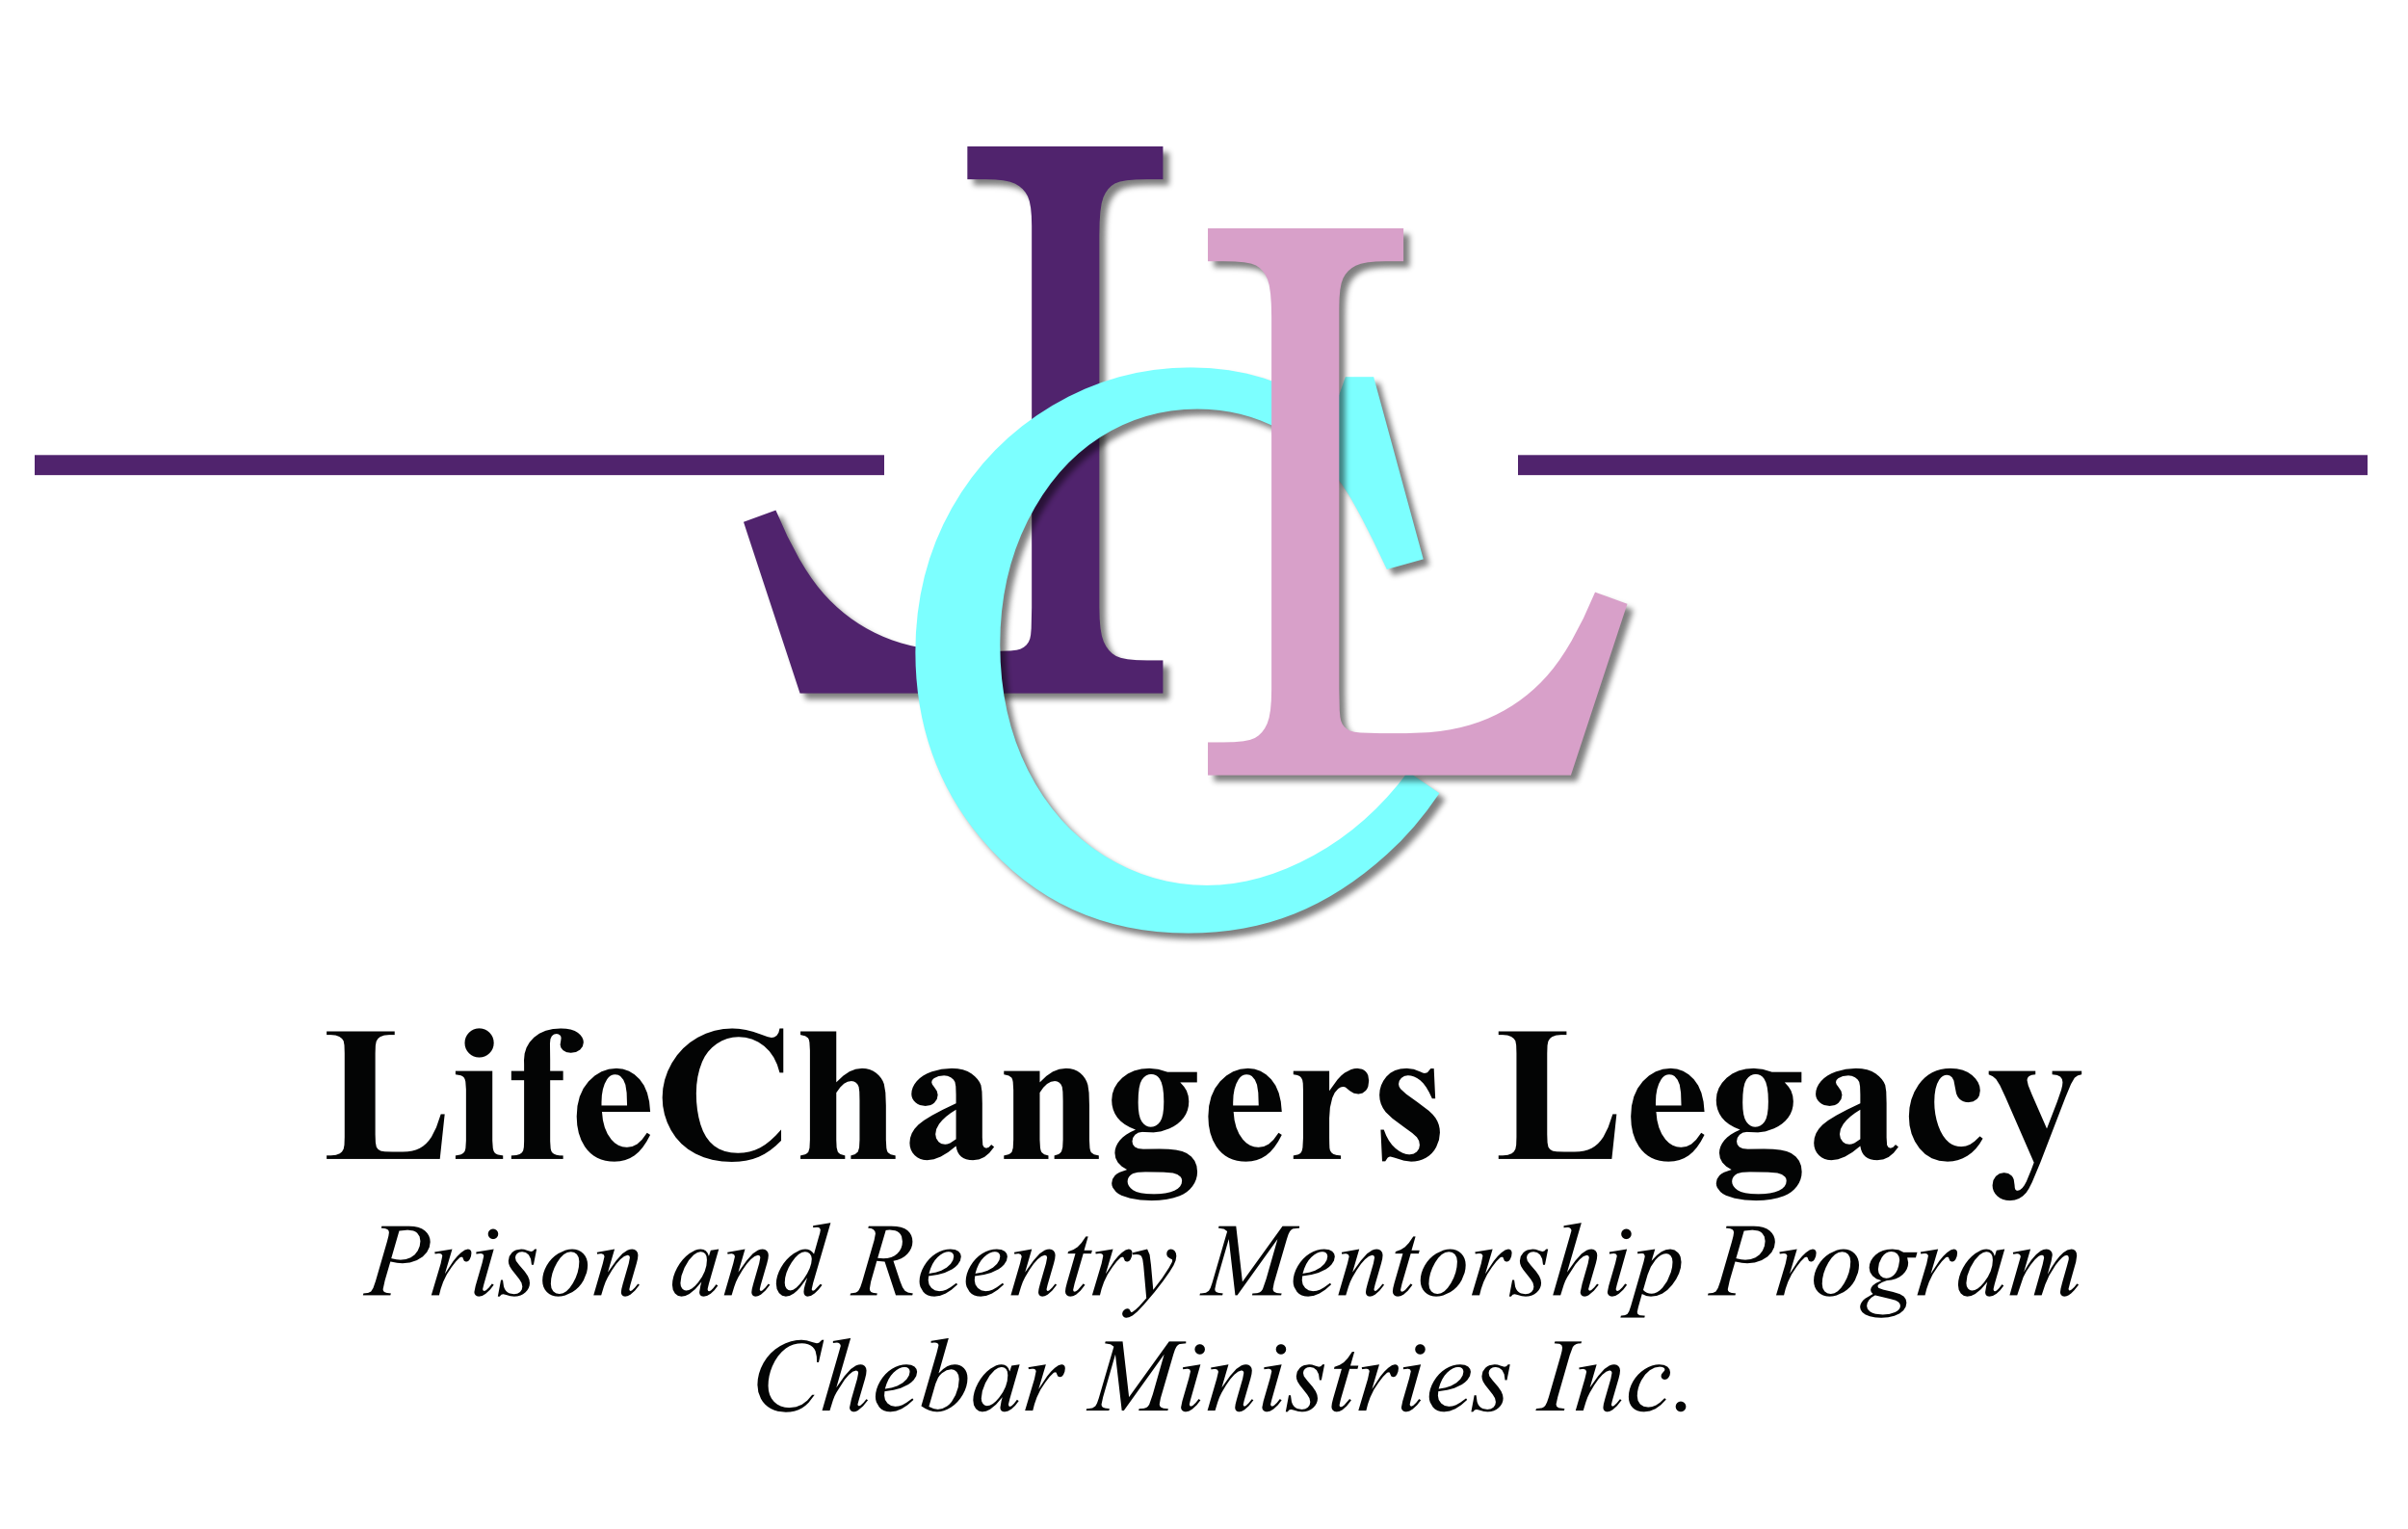

Daily Out-loud
“I AM”

Luke 1:45- “Blessed is she/he (your name here) who believes what the Lord
has spoken to you WILL BE accomplished”, in Jesus Name!

“I CAN do all things through Christ who strengthens me”, as Phil. 4:13 states. He is releasing His love and power in and through me, with every spiritual blessing, as Eph. 1: 3-23 states, “Blessed be the God and Father of our Lord Jesus Christ, who has blessed us with every spiritual blessing in the heavenly places in Christ, :4 just as He chose us in Him before the foundation of the world, that we should be holy and without blame before Him in love.” This is the day that the Lord has made and I will rejoice and be glad in it. I believe I AM always divinely guided by God, that I hear His voice and His only. I believe I AM always taking the right turn in the road, and AM guided to make right decisions. God is with me and He will see me through everything I need to succeed in this day and in my future. He is working in and through me and preparing my way. I keep my heart free from hate and my mind free from fear or worry. I AM staying in His Word for instruction and understanding, and I have the mind of Christ with godly thoughts, remembering all I learn and hear today, speaking only words of kindness and love, wisdom, knowledge and understanding. Only right and excellent things will proceed from my thoughts and words today. I believe I AM created in the image of God as Gen. 1:26 states, so I AM creative. I AM healed, I AM delivered of the old nature, I AM forgiven and forgive, I AM discerning to make right choices, I AM blessed to be a blessing to others, I AM filled with Gods wisdom, knowledge and understanding through reading His Word. I AM favored as Prov. 3:3-8 states. I AM loved, I AM lovable, I AM loving, forgetting myself and esteeming others greater than myself as Jesus does. I AM filled with honor and power as Luke 10:19 states. I AM an overcomer, and I AM a victor through Christ Jesus, my Lord and Savior. I AM accepting the opportunities to succeed He has set before me today and counting every encounter as a divine appointment by God. I AM thankful for all things in my life today, no matter where I am or how bad it looks. I AM thankful! I AM empowered to do great works for God, right where I am today. I AM steadfast in persistent faith, determined to be and do all He has created me to do. Blessed TO BE a blessing. I AM staying focused and glorify the Father in all I do. Today has been given as a gift and I AM using my time wisely and will not waste it! I AM being prepared and equipped and transformed to go forth in God’s mighty power to be His ambassador and warrior in Christ Jesus to intercede for all God’s people and battle in the Spirit. I AM taking back my “Birth-right” today! Thank You Jesus for saving me from my old-nature and creating a new unique me through You and saving me from the enemies of darkness and the deceitfulness and craftiness of this world. I do believe I AM all that I have spoken here today, in Jesus Name, Thank You Father God. “I See ME Free” _ “I AM Free”©
I AM…Truthful I Am…His Beloved
I AM…Strong I Am…Wise
I AM…Confident I Am… Healthy
I AM…Loved I Am …Wealthy
I AM…Love I Am…Royalty
I AM…Loveable I Am…Empowered
I AM…Thankful I Am…Healed
I AM…Grateful I Am...In Him
I AM…Generous I Am…Christ-like
I AM…Special I Am… Appointed
I AM…Unique by design I Am…YouNiquely Me
I AM…Beautiful inside and out I Am…Magnificent
I AM…Called into His Kingdom I Am…His
I AM…Joyful I Am…Kingdom mind
I AM…Faithful I Am…Determined
I AM…Believing I Am…Committed
I AM…Gifted I Am…Changed
I AM…Delivered I Am…Transformed
I AM…Whole I Am…Heavenly bound
I AM…Blessed I Am…In Eternity
I AM…Favored I Am…Seer in Spirit
I AM…In Abundance I Am…Prophetic
I AM…Disciplined I Am…Transparent
I AM…Created to do great things
I AM…Created in the Image of God
I AM…Filled with Christ Resurrection Power
I AM…Doing all things through Christ who strengthens me
I AM…With Eternal Youth
I AM…Built up with Revelation knowledge, understanding and wisdom
I AM…With God’s energy all day
I AM…Creating my happiness
I AM…With a Great attitude
I AM…With a Heavenly Perspective
I AM…Kingdom minded
I AM…Immovable, Unshakable, Unstoppable woman/man of God

LifeChangers Legacy,
Chebar Ministries
5665 Atlanta Hwy Ste. 102-217
Alpharetta, GA 30004
www.LifeChangersLegacy.org
Info@LifeChangersLegacy.org
678-768-1978

